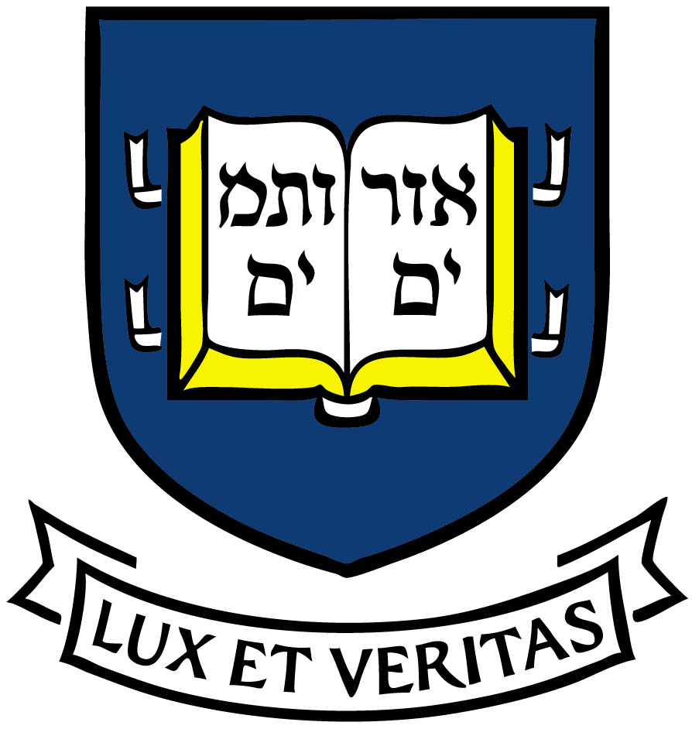
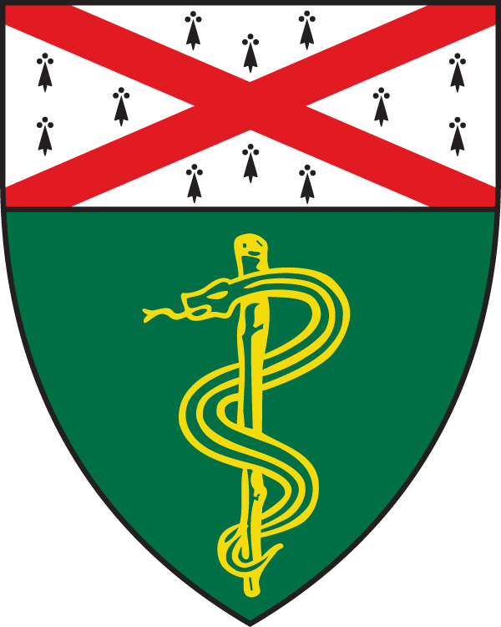
Yale School of Medicine
Postdoctoral Fellowships in Kidney Research

Postdoctoral Fellowship positions are available at Yale University in all aspects of kidney disease research including physiology, cell biology, pathology, developmental biology, genetics, vascular biology, bioinformatics, medical informatics, bioengineering, and clinical epidemiology and biostatistics.

Stipends are provided from a NIH T32 Training Grant restricted to U.S. citizens and permanent residents. Women and members of minority groups are particularly encouraged to apply.

Please email curriculum vitae, statement of research training interest, and names of possible Yale faculty mentor(s) to: Dr. Lloyd Cantley, Section of Nephrology, Yale School of Medicine, Box 208029, New Haven, CT 06520-8029. Email: Lloyd.Cantley@yale.edu. Please also arrange for three reference letters to be emailed directly to Dr. Cantley by faculty members familiar with your research ability and potential for a research career.

Postdoctoral Fellows can select as mentors any grant-funded investigator at Yale conducting kidney-related research. Examples of potential mentors include:

Peter Aronson, MD: http://medicine.yale.edu/intmed/people/peter_aronson-2.profile

Lloyd Cantley, MD: http://medicine.yale.edu/intmed/people/lloyd_cantley-2.profile

Michael Caplan, MD, PhD: http://physiology.yale.edu/faculty/michael_caplan-2.profile

William Chang, MD, PhD: https://medicine.yale.edu/people/search/w_chang.profile

Joseph Craft, MD: https://medicine.yale.edu/intmed/rheumat/people/joseph_craft.profile

Gary Desir, MD: http://medicine.yale.edu/intmed/nephrol/people/gary_desir-2.profile

Shuta Ishibe, MD: http://kidney.med.yale.edu/people/shuta_ishibe-2.profile

Richard Flavell, PhD: http://immunobiology.yale.edu/people/richard_flavell-2.profile

Julie Goodwin, MD: http://medicine.yale.edu/pediatrics/nephrology/people/julie_goodwin-2.profile

Ruslan Medzhitov, PhD: http://immunobiology.yale.edu/people/ruslan_medzhitov-2.profile

Jordan Pober, MD, PhD: http://medicine.yale.edu/immuno/programs/jordan_pober-2.profile

Mark Saltzman, PhD: https://medicine.yale.edu/profile/mark_saltzman/

William Sessa, PhD: https://medicine.yale.edu/pharm/people/william_sessa-2.profile

Stefan Somlo, MD: http://kidney.med.yale.edu/people/stefan_somlo-2.profile

Zhaoxia Sun, PhD: http://medicine.yale.edu/genetics/people/zhaoxia_sun-2.profile

Jeff Testani, MD: https://medicine.yale.edu/profile/jeffrey_testani/

F. Perry Wilson, M.D.: http://medicine.yale.edu/intmed/patr/people/francis_p_wilson-2.profile

